Regional Operational Plan DF.#R.YY-XX

Operational Plan: Alexander Creek Northern Pike Suppression

by

Parker Bradley, Cody Jacobson, and Kristine Dunker

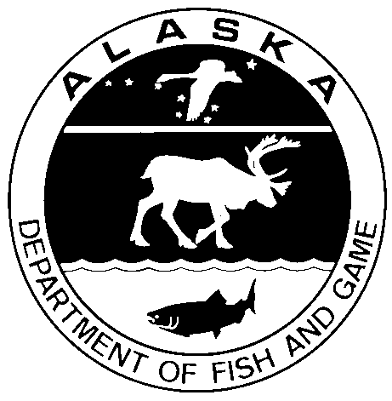

February 2019

Alaska Department of Fish and Game Divisions of Sport Fish and Commercial Fisheries

Symbols and Abbreviations

The following symbols and abbreviations, and others approved for the Système International d'Unités (SI), are used without definition in the following reports by the Divisions of Sport Fish and of Commercial Fisheries: Fishery Manuscripts, Fishery Data Series Reports, Fishery Management Reports, and Special Publications. All others, including deviations from definitions listed below, are noted in the text at first mention, as well as in the titles or footnotes of tables, and in figure or figure captions.

**Weights and measures (metric)**

centimeter cm

deciliter dL

gram g

hectare ha

kilogram kg

kilometer km

liter L

meter m

milliliter mL

millimeter mm

**Weights and measures (English)**

cubic feet per second ft3/s

foot ft

gallon gal

inch in

mile mi

nautical mile nmi

ounce oz

pound lb

quart qt

yard yd

**Time and temperature**

day d

degrees Celsius °C

degrees Fahrenheit °F

degrees kelvin K

hour h

minute min

second s

**Physics and chemistry**

all atomic symbols

alternating current AC

ampere A

calorie cal

direct current DC

hertz Hz

horsepower hp

hydrogen ion activity pH

(negative log of)

parts per million ppm

parts per thousand ppt,

‰

volts V

watts W

**General**

Alaska Administrative

Code AAC

all commonly accepted

abbreviations e.g., Mr., Mrs., AM, PM, etc.

all commonly accepted

professional titles e.g., Dr., Ph.D.,

R.N., etc.

at @

compass directions:

east E

north N

south S

west W

copyright ©

corporate suffixes:

Company Co.

Corporation Corp.

Incorporated Inc.

Limited Ltd.

District of Columbia D.C.

et alii (and others) et al.

et cetera (and so forth) etc.

exempli gratia

(for example) e.g.

Federal Information

Code FIC

id est (that is) i.e.

latitude or longitude lat. or long.

monetary symbols

(U.S.) $, ¢

months (tables and

figures): first three

letters Jan,...,Dec

registered trademark ®

trademark ™

United States

(adjective) U.S.

United States of

America (noun) USA

U.S.C. United States Code

U.S. state use two-letter abbreviations (e.g., AK, WA)

**Mathematics, statistics**

*all standard mathematical*

*signs, symbols and*

*abbreviations*

alternate hypothesis HA

base of natural logarithm *e*

catch per unit effort CPUE

coefficient of variation CV

common test statistics (F, t, χ2, etc.)

confidence interval CI

correlation coefficient

(multiple) R

correlation coefficient

(simple) r

covariance cov

degree (angular ) °

degrees of freedom df

expected value *E*

greater than >

greater than or equal to ≥

harvest per unit effort HPUE

less than <

less than or equal to ≤

logarithm (natural) ln

logarithm (base 10) log

logarithm (specify base) log2, etc.

minute (angular) '

not significant NS

null hypothesis HO

percent %

probability P

probability of a type I error

(rejection of the null

hypothesis when true) α

probability of a type II error

(acceptance of the null

hypothesis when false) β

second (angular) "

standard deviation SD

standard error SE

variance

population Var

sample var

Regional Operational plan DF.#R.YY-XX

**Alexander Creek Northern Pike Suppression**

by

Parker Bradley, Cody Jacobson, and Kristine Dunker

Alaska Department of Fish and Game, Division of Sport Fish, Anchorage

Alaska Department of Fish and Game  
Division of Sport Fish

February 2019

The Regional Operational Plan Series was established in 2012 to archive and provide public access to operational plans for fisheries projects of the Divisions of Commercial Fisheries and Sport Fish, as per joint-divisional Operational Planning Policy. Documents in this series are planning documents that may contain raw data, preliminary data analyses and results, and describe operational aspects of fisheries projects that may not actually be implemented. All documents in this series are subject to a technical review process and receive varying degrees of regional, divisional, and biometric approval, but do not generally receive editorial review. Results from the implementation of the operational plan described in this series may be subsequently finalized and published in a different department reporting series or in the formal literature. Please contact the author if you have any questions regarding the information provided in this plan. Regional Operational Plans are available on the Internet at: <http://www.adfg.alaska.gov/sf/publications/>

Parker Bradley, C. Jacobson, and K. Dunker

Alaska Department of Fish and Game, Division of Sport Fish,

333 Raspberry Road,

Anchorage, AK

99518-1565

This document should be cited as:

Bradley, P., C. Jacobson, and K. Dunker. 2019. Alexander Creek Northern Pike Suppression. Alaska Department of Fish and Game, Regional Operational Plan ROP.DF#R.YY-XX, Anchorage.

The Alaska Department of Fish and Game (ADF&G) administers all programs and activities free from discrimination based on race, color, national origin, age, sex, religion, marital status, pregnancy, parenthood, or disability. The department administers all programs and activities in compliance with Title VI of the Civil Rights Act of 1964, Section 504 of the Rehabilitation Act of 1973, Title II of the Americans with Disabilities Act (ADA) of 1990, the Age Discrimination Act of 1975, and Title IX of the Education Amendments of 1972.

**If you believe you have been discriminated against in any program, activity, or facility please write:**

ADF&G ADA Coordinator, P.O. Box 115526, Juneau, AK 99811-5526

U.S. Fish and Wildlife Service, 4401 N. Fairfax Drive, MS 2042, Arlington, VA 22203

Office of Equal Opportunity, U.S. Department of the Interior, 1849 C Street NW MS 5230, Washington DC 20240

**The department’s ADA Coordinator can be reached via phone at the following numbers:**

(VOICE) 907-465-6077, (Statewide Telecommunication Device for the Deaf) 1-800-478-3648,

(Juneau TDD) 907-465-3646, or (FAX) 907-465-6078

**For information on alternative formats and questions on this publication, please contact:**

ADF&G, Division of Sport Fish, Research and Technical Services, 333 Raspberry Rd, Anchorage AK 99518 (907) 267-2375

Signature Page

|  |  |
| --- | --- |
| Project Title: | Alexander Creek Northern Pike Suppression |
| Project leader(s): | Parker Bradley and Cody Jacobson |
| Division, Region, and Area | Division of Sport Fish, Region II, Palmer Office |
| Project Nomenclature: | Northern pike, Invasive species, Alexander Creek, Control Netting |
| Period Covered | April 2019 through June 2021 |
| Field Dates: | Approximately May 2019 - May 2021 |
| Plan Type: | Category II |

**Approval**

|  |  |  |  |  |  |  |
| --- | --- | --- | --- | --- | --- | --- |
| Title |  | Name |  | Signature |  | Date |
| Project co- leader |  | Parker Bradley |  |  |  |  |
| Project co-leader |  | Cody Jacobson |  |  |  |  |
| Biometrician |  | Ben Buzzee |  |  |  |  |
| Reginal Invasive Species Coordinator |  | Kristine Dunker |  |  |  |  |
| Research Coordinator |  | Tim McKinley |  |  |  |  |

TABLE OF CONTENTS

Page

List of Figures 2

List of appendicies 2

INTRODUCTION 3

Objectives 5

Study Area 5

Methods 6

Background 6

Study Design 8

Northern Pike Suppression 8

Salmonid Monitoring Protocol 10

Northern Pike Reward Program in Alexander Lake 12

Data Collection 12

Northern Pike Suppression 12

Salmonid Monitoring 12

Northern Pike Reward Program in Alexander Lake 12

Data Analysis 13

Schedule and Deliverables 13

RESPONSIBILITIES 14

Literature Cited 15

APPENDICES 17

# List of Figures

Figure 1. Northern pike range in Alaska. 3

Figure 2. Map of Alexander Creek. 6

Figure 3. Northern Pike CPUE (Number of pike captured per net hour) in Alexander Creek 2011–2018. 8

Figure 4. Coho salmon CPUE (average number per minnow trap) in minnow traps in Alexander Creek, 2011–2016. 11

Figure 5. Chinook salmon CPUE (average number per minnow trap) in minnow traps in Alexander Creek, 2011–2016. 11

# List of appendicies

Appendix 1. Photograph of a section of Alexander Creek from the air (top) and an example of a side channel slough along the mainstem of Alexander Creek (bottom). 18

Appendix 2. Photograph showing juvenile salmonids in the stomach of a northern pike caught in an Alexander Creek gillnet. 19

Appendix 3. Catch form. 20

Appendix 4. Northern pike sampling form. 21

Appendix 5. Alexander Creek juvenile fish minnow trapping form. 22

Appendix 6. Alexander Creek juvenile fish measurement form. 23

# INTRODUCTION

Invasive northern pike *Esox lucius* pose a significant threat to salmon habitats in Southcentral Alaska (ADF&G 2007). Northern pike are native throughout much of the state but do not naturally occur south and east of the Alaska Range (Figure 1). They were introduced by anglers to the Yentna River drainage in the late 1950’s and subsequently spread throughout the Susitna River basin through flood events and further illegal stockings (Mills 1986). It is believed that northern pike were introduced to Alexander Lake in the late 1960s, although there was no harvest record of them prior to 1985 (Mills 1986). Anecdotal accounts from Alexander Creek area residents suggest that dispersal of northern pike from the lake to the lower river occurred slowly over 10-20 years. Anglers first caught them in the lower river in the mid-1990s. Today, northern pike are widespread throughout the system. A large portion of the drainage is shallow and densely vegetated, making it ideal northern pike habitat (Morrow 1980).

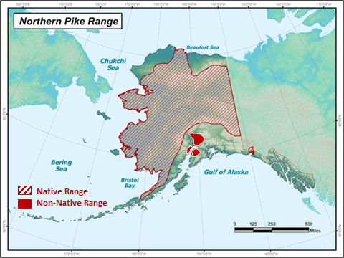

Figure . Northern pike range in Alaska.

Fisheries of Alexander Creek historically generated an average of 13,700 angler-days of effort annually for the 20-year period from 1980-1999 (Oslund and Ivey 2010). During that same period, the Chinook salmon *Oncorhynchus tshawytscha* fishery contributed greater than 90% of the expended effort, and an average of 2,880 Chinook salmon were harvested annually (Ivey et al. 2007). From 1977-2010, the peak of the sport fishery occurred in 1991 with a reported 26,235 days of effort and 6,548 Chinook salmon harvested (Whitmore and Sweet 1998), a more recent average (2001–2010) for sport fishing effort on Alexander Creek was about 2,000 angler days. Approximately eight lodges operated during this time period in which Chinook salmon were primarily targeted.

Since the late 1990s, northern pike have reduced the population size of multiple fish species in the Alexander Creek drainage. Aerial indices of escapement have shown a downward trend in Chinook salmon spawners over the past two decades culminating in the Alaska Board of Fisheries designating Alexander Chinook salmon as a Stock of Concern in 2011. The Sustainable Escapement Goal for Chinook salmon is 2,100-6,000 fish, but escapement counts dropped to less than 100 fish by 2009 (Oslund et al. 2017). The Chinook salmon sport fishery has been closed since 2008. Aerial surveys had also shown a change in the distribution of Chinook salmon spawners. Since 1992, Chinook salmon spawners have disappeared from the tributaries upstream of Alexander Lake and, by 1998, they had stopped spawning in the upper mainstem of Alexander Creek between Sucker Creek and Alexander Lake. Harvest of coho salmon has been below the historical average of 1,683 since 2004, ranging from 757 fish in 2005 to only 10 fish reported in 2008 (Ivey et al. 2007). The once popular and abundant rainbow trout and grayling fisheries were also closed to harvest in 1996 (Whitmore and Sweet 1998). Despite these fisheries becoming catch-and-release, catch rates have declined over the past 20 years for both species.

Since 2011, in an attempt to reduce northern pike abundance and increase salmonid productivity within Alexander Creek, ADF&G has been implementing a long-term northern pike suppression program. The planned efforts for 2019 and 2020 are described in detail in this Operational Plan. Northern pike suppression has been accomplished by intensively gill-netting side-channel sloughs (Appendix 1) of Alexander Creek each year until seasonal catch rates of northern pike decrease by 85%. Northern pike gillnetting has been conducted during the peak spawning period (approximately the month of May) when pike are most mobile and concentrated in the Alexander Creek sloughs. Recently, spring gill netting and reports from anglers show native species such as rainbow trout, Arctic grayling, burbot, and even sockeye salmon are becoming more numerous and occupying habitat in Alexander Lake and upper stretches of Alexander Creek, where they have been in very low abundance since northern pike arrived. As a result, we will be implementing a program focused on incentivizing the public to fish Alexander Lake for northern pike in the winter.

The Alaska State Legislature provided funding for a portion of this work. In the fall of 2010, this funding was used as non-Federal match to acquire $635K from the Alaska Sustainable Salmon Fund (AKSSF) to support the associated project activities between 2011 and 2013. In the winter of 2013, ADF&G was again awarded AKSSF funding ($563K) to continue this work between 2014 and 2016. In 2016, ADF&G was awarded a $223.6K grant from the Matanuska-Susitna Borough to continue a slightly scaled down version of this program in 2017 and 2018. For this planning period (2019-2021), the original base funding provided by the legislature will be the primary funding source for this program with an annual budget of approximately $150K per year.

The mission of ADF&G’s Sport Fish Division is “to protect and improve the state’s recreational fisheries resources”, and an objective of the Division’s strategic plan is to “minimize impacts of invasive species on fish stocks, recreational fisheries, and fish habitat”. Removing northern pike from vital salmon rearing habitat directly relates to this objective. ADF&G has an aquatic nuisance species management plan (ADF&G 2002) and an invasive northern pike management plan (ADF&G 2007). Goals and objectives in these plans address the need to remove invasive northern pike where possible and improve salmon populations that have been impacted by northern pike. Alexander Creek is recognized as the Sport Fish Division’s highest invasive northern pike control priority (ADF&G 2010). The activities proposed in this project are aligned with several plans and initiatives, and ADF&G believes this project will result in the eventual re-establishment of salmon and trout fisheries in Alexander Creek.

# Objectives

This project continues progress toward ADF&G’s long-term goal of increasing salmon abundance and restoring fisheries in the Alexander Creek drainage by suppressing the invasive northern pike population. Specific objectives of this project between 2019 and 2021are to:

1. Annually set gill nets in up to 69 side-sloughs for 3 days in each between May 1 and June 30 to target northern pike.
2. Calculate the CPUE of juvenile salmonids from minnow trap surveys in Alexander Creek after the netting season each year (June).
3. Annually remove northern pike in Alexander Lake through and incentivized angler harvest program.

**Secondary Objectives:**

1. Calculate the mean fork length and length range of northern pike in gillnet catches.
2. Document stomach contents, sex, spawning condition, and maturity information of northern pike in gillnet catches.
3. Monitor gillnet catches for PIT-tagged northern pike originating in Alexander Lake.
4. Measure salmonids in minnow traps to document mean fork length and a length range for each species sampled.
5. Document the species composition of juvenile salmonids in Alexander Creek.

# Study Area

Alexander Creek is a tributary to the Susitna River (Figure 2). The creek is approximately 40 river miles long from its mouth at the Susitna River to Alexander Lake and can be characterized as low gradient and tannin stained. Aside from Alexander Lake, several clear water tributaries draining Mount Susitna contribute to the mainstem flow. Sucker Creek enters the mainstem at river mile 20 and currently provides the majority of spawning and rearing habitat for Chinook and coho salmon. The mainstem of Alexander Creek is convoluted with numerous side channel sloughs, most of which were, at one point, part of the mainstem channel. Side channels are typically shallow, stagnant waters with low flows and can contain dense aquatic vegetation. Northern pike are well suited to these side channel habitats (Morrow 1980, Inskip 1982) and are currently widespread throughout the system.

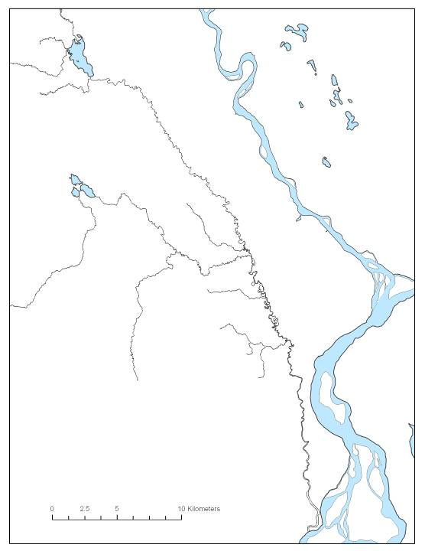

Study Reach 3

Study Reach 2

Study Reach 1

Susitna River

Yetna River

Alexander Creek

Sucker Lake

Sucker Cr.

Alexander Lake

Figure . Map of Alexander Creek.

# Methods

## Background

The primary goal of this project is to reduce the impact of invasive northern pike on rearing salmonids by removing northern pike from Alexander Creek and investigate the feasibility of an angler assisted Alexander Lake northern pike removal program. Complete eradication of northern pike in this drainage would most likely be cost and logistically-prohibitive. However, relieving some of the predation pressure on salmon fry and smolt should increase their abundance by contributing to greater survival (Muhlfeld et al. 2008). Over time, greater survival of juvenile salmon may result in larger annual returns of adult Chinook salmon. In other parts of Alaska where pike are native, and even in other drainages in Southcentral where they are not (i.e. the Deshka River), pike and salmonids are capable of coexisting; however, habitat complexity that allows salmonids opportunities for predator avoidance is hypothesized to be a strong factor in mediating predator-prey interactions within these fish communities (Sepulveda et al. 2013). In Alexander, where the entire system is comprised of homogenous habitat providing ideal conditions for pike, salmonids are unable to avoid predation and, hence, their populations drastically declined (Oslund et al. 2017). Through annual suppression of the northern pike population, ADF&G hopes to eventually restore salmonid production to levels that allow salmon fisheries to re-open in Alexander Creek.

To accomplish this, a long-term northern pike gillnetting program was established in 2011 and will continue annually. As in past years, all gillnetting will take place in side-channel sloughs of Alexander Creek. Netting will take place in the spring during the northern pike spawning period. Stomach contents will be identified from gillnetted northern pike to look for shifts in diet over time as the suppression continues from year to year. Additionally, a new program will be implemented in the winters of 2019/2020 and 2020/2021 encouraging members of the public to remove northern pike in Alexander Lake through angling.

From 2011 through 2013, ADF&G conducted a radio telemetry study of adult northern pike to investigate movement patterns between Alexander Lake and Alexander Creek. Northern pike movement data from the radio telemetry study demonstrated that few (~6%) radio-tagged adult northern pike left the lake and moved downstream into the creek, and those that did were all captured in gillnets in the sloughs (Rutz et al. 2019b). This result supported the idea that working solely within Alexander Creek sloughs and not focusing on the far costlier endeavor of pike suppression in Alexander Lake would be sufficient to meet our goal of increasing salmon production in the creek. However, in 2014, an invasive plant, *Elodea canadensis*, was discovered in the lake. Between 2014 and 2016, the elodea spread to encompass approximately 500 acres within Alexander Lake, and some areas of growth were observed to be dense enough to preclude movement by adult pike (Heather Stewart and Dave Rutz, personal observations). The Alaska Department of Natural Resources treated Alexander Lake with herbicides in 2016, but it was unsuccessful in eradicating the elodea. The lake is now nearly completely infested. It is possible that some adult pike may have been displaced downstream. The pike catch rates in gillnets has been increasing since 2015 (Figure 3), but it is unknown if elodea is the cause. Nevertheless, the potential for elodea to be displacing pike downstream is concerning as such replacement of fish removed by ADF&G nets could reduce the effectiveness of suppression efforts until the elodea population is under control. At the same time, there is evidence of native fish species beginning to recover in the upper stretches of the creek and into Alexander Lake itself. Given this, additional suppression in the lake would likely improve the recovery of those species.

Figure . Northern Pike CPUE (Number of pike captured per net hour) in Alexander Creek 2011–2018.

Finally, data on the CPUE and species composition of juvenile salmonids in Alexander Creek will be collected through minnow trap surveys to detect trends in CPUE and changes in composition. These surveys will occur annually in June. All pike collected in gillnets will also be dissected for stomach content analyses which will also provide insight into the productivity of the prey base. In addition to the minnow trap surveys, ADF&G will continue indexing adult Chinook salmon returns to Alexander Creek via aerial surveys in July.

## Study Design

### Northern Pike Suppression

In May though early June each year, a large-scale gillnetting operation will continue in side-channel sloughs of Alexander Creek. Northern pike will be targeted with up to 75 gillnets while congregated for spawning in side-channel sloughs for approximately two weeks following ice out. Two field camps will be set up along the mainstem of Alexander Creek. One will be located in the lower river between the mouth of Alexander Creek and Sucker Creek and the other will be located at the Alexander Lake outlet. Two technicians will be assigned to each field camp and will be responsible for gillnetting sloughs assigned to them. Each crew will target approximately 34 side channel sloughs for a total of 68 sloughs in all. The actual number of sloughs that are netted will be based on water levels because, at low water, some sloughs cannot be accessed. Earlier years of this project demonstrated that catch of northern pike, in many of the side-channel sloughs, can be reduced by 85% within about one week of continuous gillnetting (Rutz et al. 2019a). Recently, however, that target has been met within 3-4 days. Sloughs furthest downstream in each river section will be fished first. Sloughs will be fished with enough gillnets to fully cover the area. This will progress upstream until either all sloughs are set or all the available gillnets are deployed. Each slough has documented GPS coordinates and has been assigned a number beginning with the slough furthest downstream. Slough numbers will remain as designated for annual consistency.

Suspended variable mesh gillnets will be used at each site. Gillnet dimensions are 36 m in length by 2 m in depth and composed of four panels of different mesh sizes. The four panels of mesh are juxtaposed in increasing order of mesh size along the gillnet: 1.25” (3.1 cm), 1.5” (3.8 cm), 1.75” (4.4 cm) and 2” (5.1 cm). Nets are monofilament with a 3/8” (9.5 mm) foam top line and 30-lb lead line. One gillnet will be set within or surrounding each weed bed in a slough. Two gillnets may be fished together if the weed bed is large. If there are more weed beds than gillnets to achieve complete coverage, gillnets will be distributed as evenly as possible throughout the entire slough. Gillnets will be fished overnight and checked once every 24 hours. The first gillnet set will be the first checked. If necessary, nets may be moved or more nets set to optimize catches. If and when this happens, it will be documented in field notebooks. Netting will continue for three days in each slough. Exceptions to this protocol will be made:

1. If zero northern pike are captured in a slough in a day’s check, the nets will be pulled and moved to another slough

2. If catches of northern pike remain at or above 5 fish, nets will remain in the slough until catches fall below 5 fish

3. If significant bycatch occurs, nets will be pulled and moved to another slough.

If any of those three criteria are not met, nets in a slough will be moved after the third day. Significant bycatch is defined as catching more Arctic grayling and rainbow trout combined than northern pike in a slough. Depending on conditions, individual nets with the highest bycatch can be pulled or moved to other areas of the slough, or all nets in the slough can be pulled. All northern pike removed from gillnets will be dispatched, measured for fork length to the nearest mm, identified to sex, assessed for spawning condition (green, ripe, or spent), assessed for maturity (mature or immature), and have stomach contents identified.

It is anticipated that catch rates of northern pike will rebound between years of netting which is why annual netting will be necessary (Glick and Willette 2016). However, a study on the effectiveness of gillnetting to remove invasive northern pike from lakes on the Kenai Peninsula demonstrated that catch rates of northern pike could be substantially reduced within two years of continuous northern pike suppression (Massengill 2010). Northern pike populations in larger systems with more pike habitat are more difficult to suppress. For example, in the Yampa River, Colorado, suppression efforts initially reduced the population of northern pike, but eventually the population stopped decreasing (Zelasko et al. 2016). However, northern pike suppression efforts in Box Canyon Reservoir in Washington has resulted in a 98% decrease in relative abundance from 2012 to 2017 (Joe Maroney, personal communication). Bioenergetics modeling of other large-scale invasive fish control programs, such as the systematic removal of lake trout *Salvelinus namaycush* to conserve cutthroat trout *O. clarki* stocks in Yellowstone Lake, demonstrate that these suppression projects can dramatically reduce the predation pressure on native fishes and bolster their recovery (Ruzycki et al. 2003, Syslo et al. 2011). However, bioenergetics modeling conducted by the U.S. Geological Survey, suggests the near elimination of northern pike from Alexander Creek will be necessary for recovery of salmon productivity in the drainage (Sepulveda et al. 2015). Results of this study highlight the need to remain vigilant in Alexander Creek northern pike suppression.

### Salmonid Monitoring Protocol

The second objective of this project involves collecting the data needed for long-term monitoring of salmon abundance to evaluate the success of the northern pike suppression efforts. Several metrics will be included to monitor salmonid recovery in the Alexander system including annual minnow trap surveys of juvenile salmonids and an investigation of temporal shifts in northern pike diets.

This project will continue the long-term data set begun in 2011. The minnow trap monitoring protocol will serve to answer the following questions: Does CPUE of juvenile salmonids increase with each year of northern pike suppression? Does the species composition of juvenile salmonids change with each year of northern pike suppression? One minnow trap sampling event will take place annually in June. One field crew will be responsible for setting and checking the minnow traps during each sampling event. Sampling locations are fixed based on previous years’ surveys, and GPS coordinates of sampling locations will be provided to the field crew. There are 36 sample sites along the creek corridor that correspond to regions previously identified as ‘lower, middle, and upper’ Alexander Creek (Figure 2). Half of the sample sites are located in the mainstem of Alexander Creek, and half of them are located in side-channel sloughs. During sampling events, five minnow traps will be set in each of the sample sites (n=36). Therefore, the field crew will be responsible for setting and sampling a total of 180 traps per sampling event (36 sites x 5 traps). Traps will be fished for approximately 24 hours and baited with salmon roe. All fish will be recorded to species level, enumerated, and measured for fork length.

Trends in CPUE and species composition of all captured species will be monitored over time. If salmonid CPUE, specifically for Chinook and coho salmon juveniles annually increase, this will be considered a measure of success. To date, there appears to have been a significant increase in juvenile coho salmon minnow trap catch rates (Slope = 0.025, p = 0.002, Figure 4) suggesting their abundance may be increasing. However, the minnow trap catch rates of Chinook salmon are not significantly increasing (Slope = 0.003, p = 0.441, Figure 5). Minnow traps are logistically very good tools for this sort of monitoring, and Chinook and coho salmon juveniles tend to recruit well to the gear (Swales 1987, Bryant 2000). However, minnow traps have inherent biases that have been well documented in the literature (Hubert 1996, Jackson and Harvey 1997, Layman and Smith 2001) and up to 15% to 30% variability in salmonid catch rates can be expected between years (McPherson et al. 1998, Pahlke et al. 2010). Therefore, inter-annual variation in catches has to be interpreted with this is mind. However, over time, a significant increasing trend in juvenile salmonid abundance, especially among Chinook and coho salmon, will serve as a positive indicator that pike suppression is benefitting salmonid productivity in the drainage.

Figure . Coho salmon CPUE (average number per minnow trap) in minnow traps in Alexander Creek, 2011–2016.

Figure . Chinook salmon CPUE (average number per minnow trap) in minnow traps in Alexander Creek, 2011–2016.

Another compliment to the juvenile salmonid minnow trap monitoring will be to investigate shifts in northern pike diet over time as the suppression efforts continue. All or nearly all of the northern pike that are removed in gillnets during the suppression project will be dissected to enumerate prey species in their stomach contents (Appendix 2). Stomach contents will be recorded in the field to taxonomic order for undigested invertebrates and lowest taxonomic level possible for undigested fish. Shifts in northern pike diet will be evaluated by observing changes in the species composition of prey over time.

### Northern Pike Reward Program in Alexander Lake

The third objective of this project involves a new pilot program designed to remove northern pike from Alexander Lake while minimizing cost to ADF&G. Approximately 200 northern pike will have a small PIT tag inserted in their cheek muscle in the summer/fall of 2019. The program will begin January 2020 and be advertised to anglers that a reward will be offered on returned tags. The tags will not be visible to the angler, so anglers will be encouraged to retain the heads of all the northern pike they catch. Heads brought to the Palmer ADF&G office will be scanned with a PIT tag reader. No rewards will be offered for pike with no tag in order to ensure harvested pike come from Alexander Lake. The program will end in April 2020. If successful, the program will be repeated and an additional 200 northern pike will be tagged summer/fall of 2020. The reward program will begin again in January 2021 through April 2021. Only northern pike PIT tagged in 2020 will be eligible for the 2021 reward.

The first 37 anglers that return a pike head with a tag each winter will be awarded a Visa gift card worth $100. Additionally, for every tag returned, the anglers name will be entered for a drawing at the end of the season for a Visa gift card worth $1,000. The reason the open water season will not be included is to not encourage additional floatplane traffic on Alexander Lake while it is heavily infested with elodea.

## Data Collection

### Northern Pike Suppression

All fish captured in the northern pike suppression gillnets will be counted, identified to species, and recorded on the catch form (Appendix 3). All pike will be measured to the nearest millimeter of fork length and recorded. Set and check times will be recorded for each slough. Each slough is referenced by number (see Sampling Methods above) in consecutive order beginning with the slough furthest downstream. Biological information such as fork length, sex, maturity, spawning condition, and stomach contents from each northern pike will be recorded on the northern pike sampling form (Appendix 4).

### Salmonid Monitoring

All fish captured in minnow traps during the salmonid monitoring will be enumerated by species. All salmonid individuals will be measured to fork length in mm, except for large catches where measurements will not be taken after 20 individuals have been sampled. After the fish have been measured, they will be released alive. Data for each catch will be recorded on data sheets (Appendices 5 and 6).

### Northern Pike Reward Program in Alexander Lake

When an angler comes into the office with pike heads to turn in, all heads will be scanned with a PIT tag reader. Whether or not a tag is detected, the total number of pike heads and the estimated number of hours the angler fished will be recorded to get a general idea of their CPUE. If a tag is detected, we will record the tag number, along with the angler’s contact information for their entry into the $1,000 Visa gift card drawing.

When the reward program ends in April of 2020 and 2021, the total number of northern pike harvested along with total project costs will be calculated for a cost/benefit analysis to determine if this program should be expanded to other water bodies.

## Data Analysis

Northern pike CPUE can be calculated for each slough, each section of the creek, or all data pooled together using equation 1. For the salmonid monitoring, the CPUE of all juvenile salmonids in the minnow trap surveys will be calculated annually by dividing the number of salmonids captured by the number of traps set. Efforts will be made to keep a consistent 24-hour soak time for each trap, although deployment and check times will be recorded for each trap.

|  |  |
| --- | --- |
|  | (1) |

Simple linear regression analysis will be used to evaluate if CPUE of juvenile salmonids is increasing as the northern pike suppression continues.

The species composition of juvenile salmonids will be estimated from the pooled minnow trap surveys as well as:

|  |  |
| --- | --- |
|  | (2) |

where:

|  |  |
| --- | --- |
| *ni*= | the number of salmonids of species *i* |
| *n*= | the total number of salmonids captured in the minnow traps |

The variance of the proportion will be estimated (Cochran 1977) as follows:

|  |  |
| --- | --- |
|  | (3) |

# Schedule and Deliverables

|  |  |
| --- | --- |
| April 2019: | Purchase equipment and field camp gear Hire field crews |
| May 2019: | Establish field camps Conduct gillnet suppression |
| June 2019: | Conduct minnow trap sample event |
| August 2019: | PIT tag 200 northern pike |
| October 2019 | Analyze data and write FDS report |
| April 2020: | Purchase equipment and field camp gear Hire field crews  Conclude first year of northern pike reward program |
| May 2020: | Establish field camps Conduct gillnet suppression |
| June 2020: | Conduct minnow trap sample event |
| August 2020: | PIT tag 200 northern pike |
| October 2020: | Analyze data and write FDS report |
| April 2021: | Purchase equipment and field camp gear  Hire field crews  Conclude second year of northern pike reward program |
| May 2021: | Establish field camps  Conduct gill net suppression |
| June 2021: | Conduct minnow trap sample event |

# RESPONSIBILITIES

Personnel: Parker Bradley, Fishery Biologist II, Alaska Department of Fish and Game, Sport Fish Division.

Duties: Serve as the primary project biologist; Plan and coordinate field logistics; Project reporting and presentations to the public.

Personnel: Cody Jacobson, Fishery Biologist I, Alaska Department of Fish and Game, Sport Fish Division.

Duties: Assist with planning and coordinating field logistics; Training field crews; Assist with project reporting and presentations to the public.

Personnel: Kristine Dunker, Fishery Biologist III, Alaska Department of Fish and Game, Sport Fish Division

Duties: Provide oversight and make recommendations on study designs and project plans; assist with data analysis and project reporting; coordinate and assist with the completion of project deliverables.

Personnel: Ben Buzzee, Biometrician I, Alaska Department of Fish and Game, Sport Fish Division.

Duties: Provide guidance on study design; Assist with post-season data analysis. Review project operational plans and reports.

During each field season, four fish and wildlife technicians will be hired to assist with the field activities.

# Literature Cited

ADG&G (Alaska Department of Fish and Game). 2002. Alaska Aquatic Nuisance Species Management Plan. Alaska Department of Fish and Game. Juneau, Alaska.

ADF&G (Alaska Department of Fish and Game). 2007. Management plan for invasive northern pike in Alaska. Alaska Department of Fish and Game, Southcentral Northern Pike Control Committee, Anchorage, Alaska.

ADF&G (Alaska Department of Fish and Game). 2010. Region II Invasive Northern Pike Priorities. *Memorandum*. Alaska Department of Fish and Game, Division of Sport Fish. Anchorage. 34 pp.

Bryant, M.D. 2000. Estimating Fish Populations by Removal Methods with Minnow Traps in Southeast Alaska Streams. North American Journal of Fisheries Management 20: 923-930.

Glick, W.J. and T.M. Willette. 2016. Relative abundance, food habits, age, and growth of northern pike in 5 Susitna River drainage lakes, 2009-2012. AK Dept. of Fish and Game, FDS No. 16-34, Anchorage.

Hubert, W.A. 1996. Passive Capture Techniques. Pages 157–192 in B.R. Murphy and D.W. Willis, editors. Fisheries Techniques, 2nd edition. American Fisheries Society. Bethesda, Maryland.

Inskip, P. D. 1982. Habitat suitability index models: northern pike. U.S. Department of Interior, Fish and Wildlife Service, FWS/OBS-82/10.17. 40pp.

Ivey, S., C. Brockman and D. Rutz. 2007. Overview of Northern Cook Inlet Area sport fisheries with proposals under consideration by the Alaska Board of Fisheries, February 2008. Alaska Department of Fish and Game, Fishery Management Report NO. 07-65, Anchorage.

Jackson, D.A. and H.H. Harvey. 1997. Qualitative and quantitative sampling of lake fish communities. Canadian Journal of Fisheries and Aquatic Sciences. 54: 2807-2813.

Layman, C.A. and D.E. Smith. 2001. Sampling bias of minnow traps in shallow aquatic habitats on the Eastern Shore of Virginia. Wetlands 21:145-154.

Massengill, R. L. 2010. Control efforts for invasive northern pike on the Kenai Peninsula, 2005-2006. Alaska Department of Fish and Game, Fishery Data Series No. 10-05, Anchorage.

McPherson, S.A., R.J. Yanusz, D.R. Bernard and M.S. Kelley. 1998. Production of coho salmon from the Taku River, 1996-1997. Alaska Department of Fish and Game, Fishery Data Series No. 98-18, Anchorage.

Mills, M. J. 1986. Alaska statewide sport fish harvest studies - 1985 data. Alaska Department of Fish and Game, Federal Aid in Fish Restoration and Anadromous Fish Studies, Annual Performance Report 1985-1986, Project F-10-1, 27 (RT-2), Juneau.

Morrow, J. E. 1980. The freshwater fishes of Alaska. Alaska Northwest Publishing Company, Anchorage, Alaska. 248 pp.

Muhlfeld, C.C., D.H. Bennet, R.K. Steinhorst, B.Marotz, and M. Boyer. 2008. Using bioenergetics modeling to estimate consumption of native juvenile salmonids by nonnative northern pike in the upper Flathead River system, Montana. North American Journal of Fisheries Management 28: 636-648.

Oslund, S., S. Ivey, and D. Lescanec. 2017. Area management report for the recreational fisheries of northern Cook Inlet, 2014–2015. Alaska Department of Fish and Game, Fishery Management Report No. 17-07, Anchorage.

Oslund, S and S. Ivey. 2010. Recreational Fisheries of Northern Cook Inlet, 2009-2010: Report to the Alaska Board of Fisheries, February 2011. Alaska Department of Fish and Game, Fishery Management Report No. 10-50, Anchorage.

Pahlke, K.A., P. Richards, and P. Etherton. 2010. Production of Chinook salmon from the Stikine River, 1999-2002. Alaska Department of Fish and Game, Fisheries Data Series. No. 10-03, Anchorage.

Rutz, D., P. Bradley, C. Jacobson, and K. Dunker. 2019a. Alexander Creek Northern Pike Suppression. Alaska Department of Fish and Game, Fishery Data Series Report No. In Press, Anchorage.

Rutz, D., K. Dunker, P. Bradley, and C. Jacobson. 2019b. Movement Patterns of Northern Pike in Alexander Lake. Alaska Department of Fish and Game, Fishery Data Series Report No. In Press, Anchorage.

Ruzycki, J.R., D.A. Beauchamp, and D.L. Yule. 2003. Effects of introduced lake trout on native cutthroat trout in Yellowstone Lake. Ecological Applications 13:23–37.

Sepulveda, A.J., D.S. Rutz, S.S. Ivey, K.J. Dunker and J.A. Gross. 2013. Introduced northern pike predation on salmonids in southcentral Alaska. Ecology of Freshwater Fish 22: 268-279

Sepulveda, A. J., D. S. Rutz, A. W. Dupuis, P. A. Shields, K. J. Dunker. 2015. Introduced northern pike consumption of salmonids in Southcentral Alaska. Ecology of Freshwater Fish. 24:519–531.

Swales, S. 1987. The use of small wire-mesh traps in sampling juvenile salmonids. Aquaculture Research 18:187–195.

Syslo, J.M., C.S. Guy, P.E. Bigelow, P.D. Doepke, B.D. Ertel and T.M. Koel. 2011. Response of non-native lake trout (*Salvelinus namaycush*) to 15 years of harvest in Yellowstone Lake, Yellowstone NP. Canadian Journal of Fisheries and Aquatic Sciences. 68:2132–2145.

Whitmore, C. and D. Sweet. 1998. Area management report for the recreational fisheries of Northern Cook Inlet, 1997. Alaska Department of Fish and Game, Fishery Management Report Nol. 98-4. Anchorage.

# 

APPENDICES

Appendix . Photograph of a section of Alexander Creek from the air (top) and an example of a side channel slough along the mainstem of Alexander Creek (bottom).

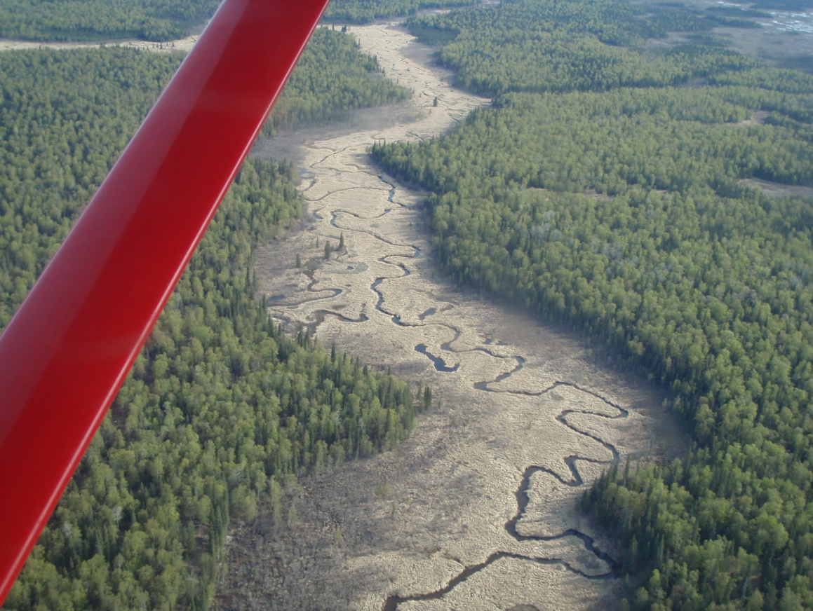

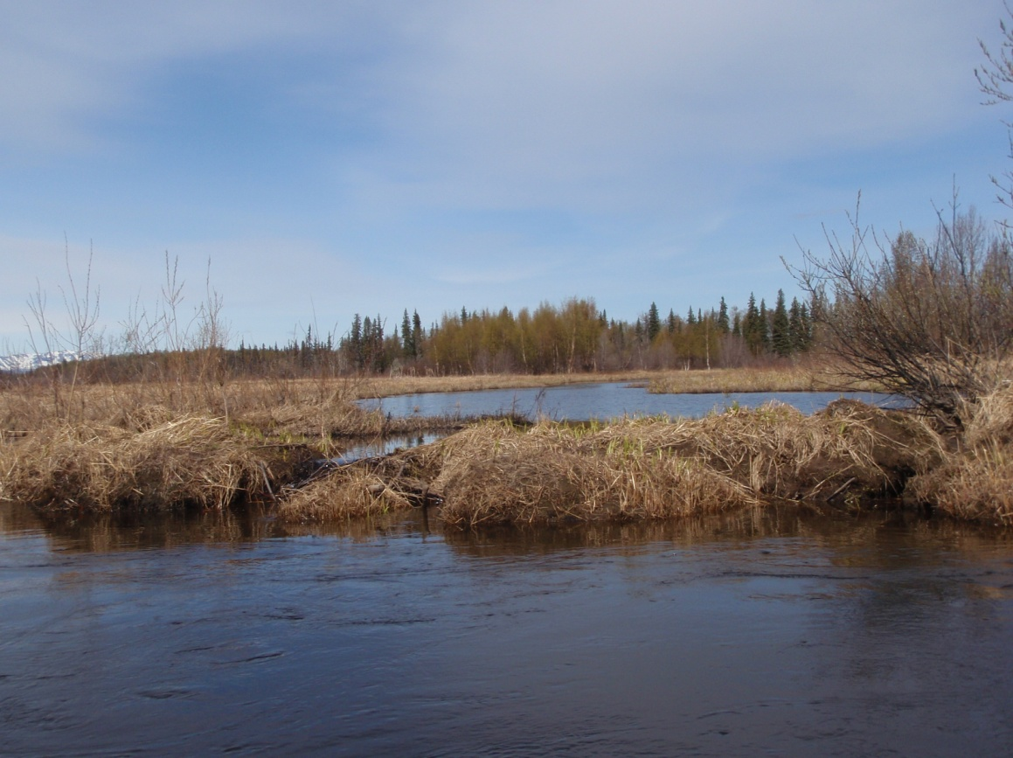

Appendix . Photograph showing juvenile salmonids in the stomach of a northern pike caught in an Alexander Creek gillnet.

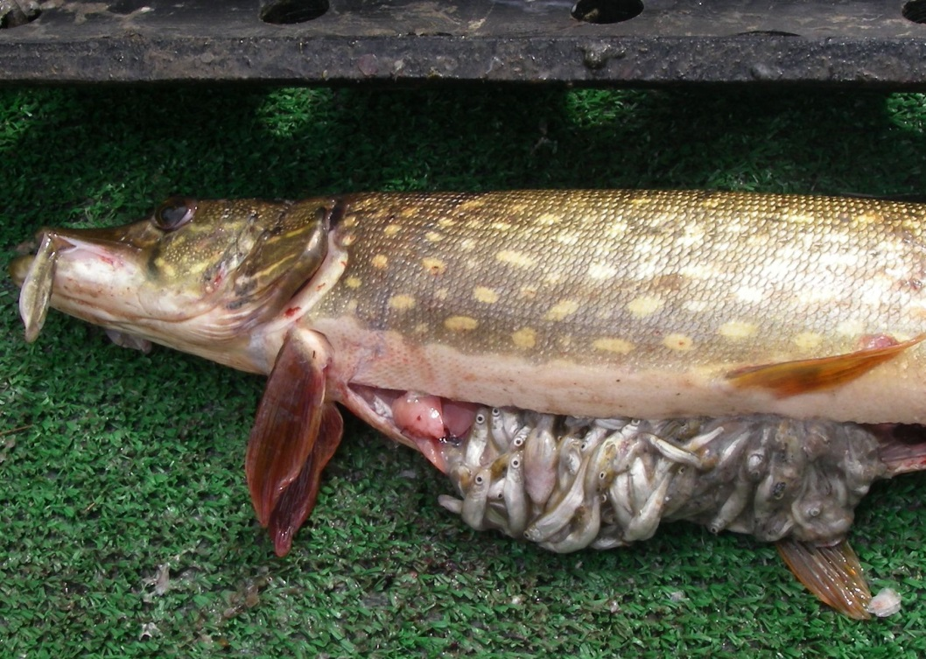

Appendix . Catch form.

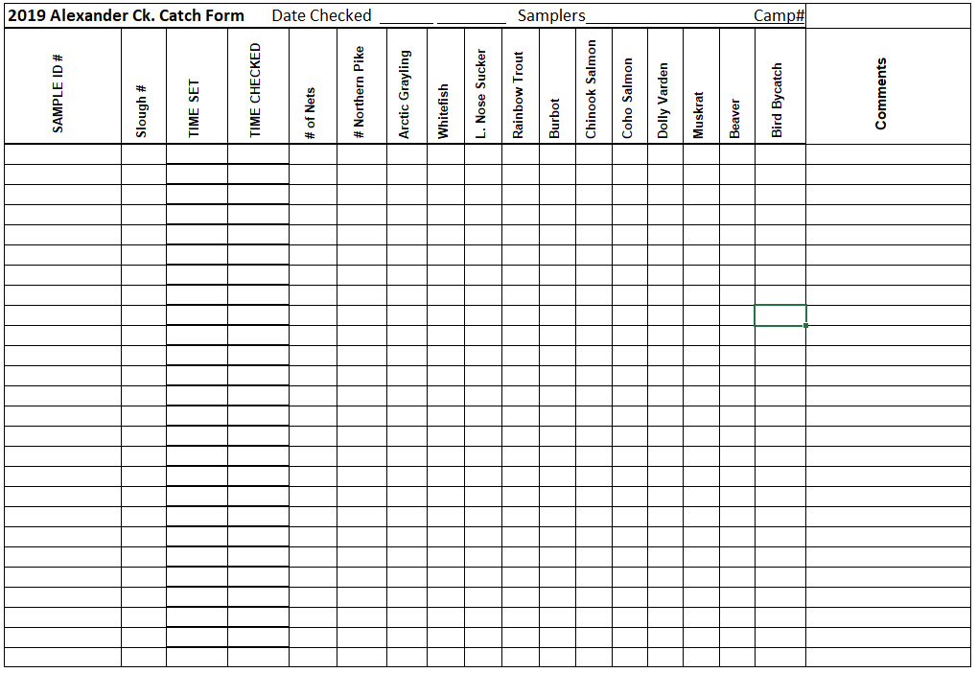

Sample ID #: slough #-Date. i.e. 12-51719 (slough 12-May 27, 2019)

Appendix . Northern pike sampling form.



Appendix . Alexander Creek juvenile fish minnow trapping form.



Appendix . Alexander Creek juvenile fish measurement form.

